

***SkillCourt 7.0***

**User Manual**

Alvaro Silva, Developer

Chandan Aubel, Developer

Antonio Riverol, Developer

April 2017

**Revision Sheet**

|  |  |  |
| --- | --- | --- |
| **Release No.** | **Date** | **Revision Description** |
| 1.0 | 12/8/2016 | Initial Revision |
| 2.0 | 4/28/2017 | Second Revision |
|  |  |  |
|  |  |  |
|  |  |  |
|  |  |  |

**USER'S MANUAL**

**TABLE OF CONTENTS**

Page #

1.0 GENERAL INFORMATION 1-1

1.1 System Overview 1-1

2.0 SYSTEM SUMMARY 2-1

2.1 System Configuration 2-1

2.2 User Access Levels 2-2

3.0 GETTING STARTED 3-1

3.1 Registering and Signing-in 3-1

3.2 Player role 3-1

**1.0 GENERAL INFORMATION**

# GENERAL INFORMATION

## 1.1 System Overview

SkillCourt is an interactive training system that measures, challenges and improves an athlete's physical and cognitive abilities.

The SkillCourt app will allow soccer players to practice their passing accuracy and response time on the field. This document is going to allow user of the app to discover the functionalities the app provides so they can get the most out their training.

**1.2 User Manual**

This manual was edited from the last version and version 7.0 added the new features.

**2.0 SYSTEM SUMMARY**

# SYSTEM SUMMARY

## 2.1 System Configuration

The system is compounded by 3 main elements: The Android App, the pads and a database. Users will also need a soccer ball.

The android app will connect to the pad via Wi-Fi, and also will connect to the database in real time where users’ login, statistics and other information is saved.

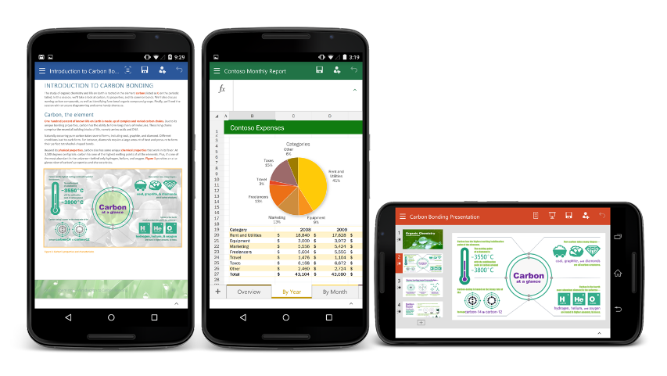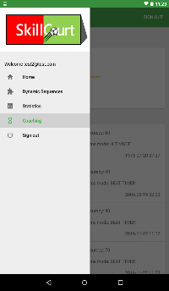

Database Online Communication



## 2.2 User Access Levels

Two user roles are defined. By default, when a new user registers in the app would have the role of a player, later on he/she can choose to enroll as a coach, he/she will keep all the functionalities of a payer but will have some more functionalities that will be explained in this document.

**3.0 GETTING STARTED**

# GETTING STARTED

## 3.1 Registering and Signing-in

Once the app is installed you need to register in order to have access to the app functionalities. When you register you would have by default the role of a player, this role allows you to create dynamic sequences, play with random or previously created sequences in beat timer or hit mode and save your statistics to review later:

* Open the app and click on register
* Provide your email address and a password
* Your session will automatically start
* When you sign out and want to sign in again, press Sing-In this time
* Provide the email address and password used when registered.

## 3.2 Player role

As it was mentioned before, this role would allow you to create dynamic sequences, play with random or previously created sequences in beat timer or hit mode and save your statistics to review later

* + 1. To create a sequence

Players can create custom sequences to make them easier or harder that the random ones to adapt the level of difficulty when playing

* Once signed-in, when you see your main dashboard with an overview of your most recent games click on the sliding “hamburger” menu icon.
* When the menu is displayed click on Dynamic Sequences
* Choose how many steps you want to specify
* Choose for each step which pad you what to be light-in green
* Provide a name for the sequence and click save.
  + 1. To play
* Once signed-in, on your dashboard click on the floating button at the bottom right corner of your screen
* Select for how long you would like to play
* Select if you want to play on Hit Mode of Beat Timer Mode
* Select the sequence you want to play from the dropdown
* Click on start
  + 1. To view statistics
* Once signed-in, when you see your main dashboard with an overview of your most recent games click on the sliding “hamburger” menu icon.
* Select the Statistics option
* You would be presented 3 tabs
  + One shows you your score on the last game and your total games played
  + The second one show you the history of your accuracy on the games played
  + The third one will show you the green and red bar graph of your history of games.
    1. Send Invitation
* Once signed-in, when you see your main dashboard with an overview of your most recent games click on the sliding “hamburger” menu icon.
* Select Multiplayer
* Click in Challenge Player
* Click in the magnifying glass icon in top right
* Introduce the email of the player you want to challenges
* Confirm that is the player you want to invite
  + 1. Create a Room
* Once signed-in, when you see your main dashboard with an overview of your most recent games click on the sliding “hamburger” menu icon.
* Select Multiplayer
* Click in Enter Lobby
* Click in Create New Room
* Add name
  1. Coach Role

The coach role will allow you, on top of your regular player functionalities, follow the progress of other players, as a coach. You can organize the players that you are going to follow into teams.

* + 1. Add coaching features
* Once signed-in, when you see your main dashboard with an overview of your most recent games click on the three dots on the upper right corner of the screen
* Select the option Add Coaching
* Click OK! On the confirmation pop-up
* Now when you go to the sliding menu you will see a new option called Coaching
  + 1. Create a team
* Once signed-in, when you see your main dashboard with an overview of your most recent games click on the sliding “hamburger” menu icon.
* Select Coaching
* Click on the plus floating button on the lower right corner of the screen when you see your list of teams
* Provide a name and a description for your team
* Click on Save
* The app will take you back to your list of teams showing the new team you just created at the bottom of the list.
  + 1. Search and add user to team
* Once signed-in, when you see your main dashboard with an overview of your most recent games click on the sliding “hamburger” menu icon.
* Select Coaching
* Select one of your team
* On the teams details screen, click on the floating button on your right below the team logo
* On the next screen tap the search icon to expand the search box
* Type the user’s email you want to add to your team
* From the result’s list select the player you want to add
* On the pop-up, provide a nickname for the player
* Click Ok and the app will take you back to your team’s detail including the new player showing at the end of the list.
  + 1. View player statistics
* Once signed-in, when you see your main dashboard with an overview of your most recent games click on the sliding “hamburger” menu icon.
* Select Coaching
* Select the team where the player you want to watch the statistics for is added
* On the teams detail screen, select from the list the player whom statistics you want to check.